## ****What is SOAP UI?****

* SOAP UI is the leading open source cross-platform API [Testing](https://www.guru99.com/software-testing.html) tool
* SOAPUI allows testers to execute automated functional, regression, compliance, and load tests on different Web API.
* SOAPUI supports all the standard protocols and technologies to test all kinds of API's.
* SOAPUI interface is simple that enables both technical and non-technical users to use seamlessly.

## Why use SOAPUI?

SOAPUI is not just a functional Api Testing tool but also lets us perform non-functional testing such as performance and security test.

Let us discuss the 5 important features of SOAPUI

**1) Functional Testing**

* A powerful tool allows testers to write Functional API Tests in SoapUI
* Supports Drag-Drop feature which accelerates the script development
* Supports debugging of tests and allows testers to develop data driven tests.
* Supports Multiple Environments - Easy to switch between QA, Dev and Prod Environments
* Allows advanced scripting (tester can develop their custom code depending on the Scenario)

**2) Security Testing**

* Has the capability to perform a complete set of vulnerability scan.
* Prevents SQL Injection to secure the databases
* Scans for Stack overflows that are caused by documents huge in size
* Scans for Cross Site Scripting, which usually occurs when service parameters are exposed in messages.
* Performs Fuzzing scan and Boundary scan to avoid erratic behavior of the services.

**3) Load Testing**

* Distribute the Load Tests across any number of loadUI Agents.
* Simulate high volume and real-world load testing with ease.
* Allows Advanced custom reporting to capture performance parameters.
* Allows End-to-End System Performance Monitoring

**4) Supported Protocols/Technologies:**

* SoapUI has the most comprehensive Protocol Support
  + **SOAP –** Simple Object Access Protocol
  + **WSDL-** Web Services Definition Language
  + **REST-** Representational state transfer
  + **HTTP –** Hyper Text Transfer Protocol
  + **HTTPS-** Hyper Text Transfer Protocol Secured
  + **AMF –** Action Message Format
  + **JDBC-** Java Database Connectivity
  + **JMS –** Java Messaging Services

|  |  |  |
| --- | --- | --- |
| SOAP UI | ****Selenium**** | |
| SOAP UI is NOT used for User Interface Testing. It is only used for WebAPI or WebService Testing | | **Selenium is used for User Interface Testing.** |
| Capability to test the data sent and received between the web browser and a web server. Can test the protocols/technologies such as REST, SOAP. | | **Selenium cannot test protocols, but they can test the UI behaviour.** |
| Able to perform functional, load and Security Testing of the above-mentioned technologies. | | **Selenium can perform only Functional Testing. Performance Testing to some extent because we can track execution time with regards to the performance but cannot test multi user. Selenium certainly cannot be used for security testing.** |
| It is PROTOCOL Dependent and NOT browser dependent. | | **Selenium depends on the browser capabilities.** |

## SOAP UI Vs SOAP UI PRO

There are two flavors of SOAP UI, One being SOAP UI (Open source version) while the other one is SOAP UI PRO. Let us understand the difference between these two flavors and we will also discuss when to go for use what.

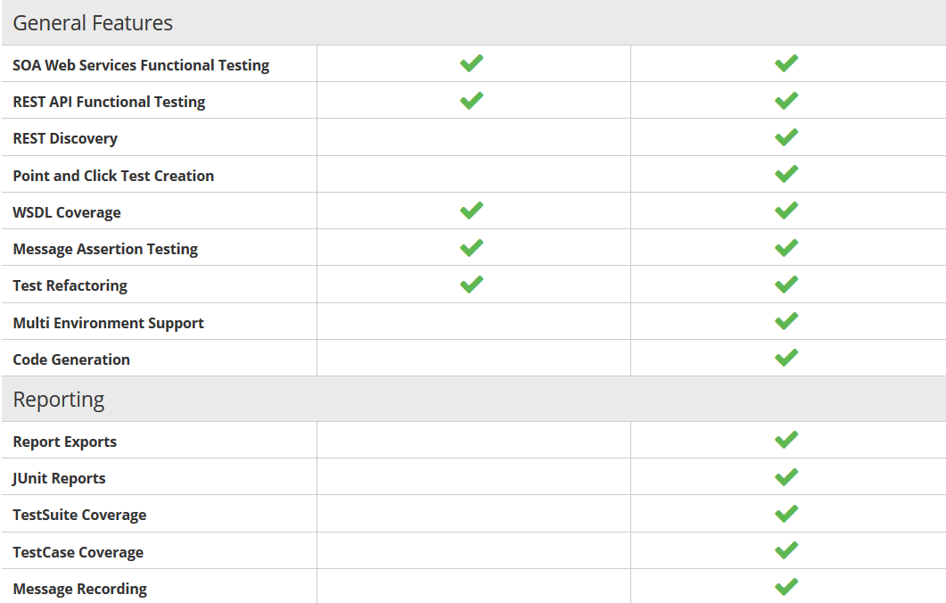

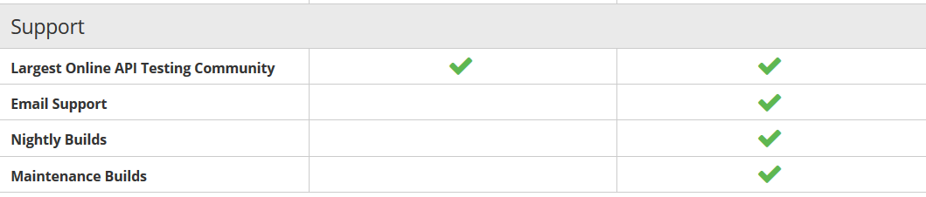

## When use SoapUI PRO Version?

**Data Driven:** PRO Version, helps us to work with an external data source such as text files, XML, Groovy, Excel, file, and Databases. This helps us to scale our tests with a range of inputs driven through the above sources.

**Test Coverage:** PRO Version allows testers to get a statistic report which shows the functionalities that are well tested and also the areas that are NOT thoroughly tested as well. The drill down reports even pinpoints exactly what has NOT been tested and what has NOT been asserted.

**Test Debugging:** You can then run the test to that breakpoint and view the current value of the SoapUI properties. The Test Debugging Interface simplifies following Test Flow, Variables, Properties, Requests, Context, and much more, making test creation and improvement more streamlined.

**Multi-Environment Support:** Working with multiple environments such as DEV, QA, Pre-PROD environment can be a daunting task with the open source version as testers need to change the end points to execute in different environments. PRO version helps us to switch between environments seamlessly.

**Reporting:** PRO version is loaded with many options to customize reports that generate detailed reports at Project, TestSuite, TestCase or LoadTest level. It also produces reports in various formats such as PDF, HTML, Word or Excel.

**Security Testing:** BothSOAP UI versions has capabilities to test for security vulnerabilities such as XML bombs, SQL injections, fuzzing, cross-site scripting. However, only SOAP UI PRO can perform vulnerability scans using Security Test Generator using a mouse click.

**SQL Builder:** For Non-Technical testers writing complex SQL Query can be cumbersome. The SOAP UI PRO's SQL Builder can help them in creating SQL Query using the SQL Builder's graphical interface. This feature helps us to accelerate the implementation of data-driven testing.

**Support**: As part of the license agreement SOAP UI Pro has exclusive support apart from the online forum support.